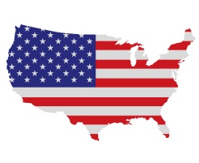
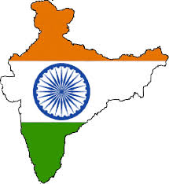Greater Charlotte Association of American Physicians of Indian origin.
Membership form.

- Annual membership: $ 75. ( valid from Nov 1,2014 to Oct 31 2015)

- Life membership: $ 750.
Details:
Name:…………………………………………………………………………………………………….
Specialty:………………………………………………………………………………………………..
Medical School:………………………………………………………………………………………………………………………..
Family :………………………………………………………………………………………………………………………………………….
Address: …………………………………………………………………………………………………………………………………………
…………………………………………………………………………………………………………………………………………………………
Email:………………………………………………………………………………………………………………
Tel:.......................................................................................................................
Practice Location:………………………………………………………………………………………………………………………………
Payment method: …………………………………………………………………………………….
Payment date:…………………………………………………………………………………………..

Signature:……………………………………………………………………………………………………

